

DEPARTMENT OF COMPUTER SCIENCE WITH ARTIFICIAL INTELLIGENCE

IBM PROJECT
BANK MARKETING TARGET ANALYSIS
Submitted by
PRAVEENA.D(222511545)
ROSELIN.M(222511547)
HEMA LATHA.B(222511540)

BACHELOR OF SCIENCE IN COMPUTER
SCIENCE WITH ARTIFICIAL INTELLIGENCE

Under the guidance of
MR.KAVIN CHAKARAVARTHI V M- Corporate Trainer

2025 - 2026

DECLARATION

We,PRAVEENA D, ROSELIN M, AND HEMA LATHA B, hereby declare that this project report on “BANK MARKETING TARGET ANALYSIS” submitted to the University of Madras in partial fulfillment of the requirement for the award of the Degree Bachelor of Computer Science with Artificial Intelligence under the guidance of MRS CAROLIN JOSHIBA., HEAD OF DEPARTMENT and MR.KAVIN CHAKARAVARTHI V M has not been submitted earlier to any other university or institute for the award of any degree.

PRAVEENA D
ROSELIN M
HEMA LATHA B

Place: PADUR
Date: 03/02/2026

BONAFIDE CERTIFICATE
This is to certify that the project titled “BANK MARKETIN TARGET ANALYSIS” is the bonafide work done by, PRAVEENA D, ROSELIN M, HEMA LATHA B. A hereby and first-year student of Jeppiaar College of Arts and Science, Padur, Chennai in partial fulfillment of the requirement for the award of the Degree of Bachelor of Computer Science with Artificial Intelligence 2025-2026.

PROJECT GUIDE: HEAD OF THE DEPARTMENT:

Mr. KAVIN CHAKARAVARTHI V M MRS CAROLIN JOSHIBA S

Date: 03/02/2026

S. No | INDEX | Page No
 | Introduction
 | Abstraction
Overview
• Helps identify customers likely to subscribe to term deposits
• Uses customer demographic and financial information
Problem statement
• Low success rate in traditional bank marketing campaigns
• High marketing costs due to untargeted customer contact
Methedology
- Data Collection
- Data Preprocessing
Visualization
• Bar charts for job and education vs subscription
• Pie charts for response distribution

 | Conclusion
 | References

INTRODUCTION:

The Bank Marketing Target Analysis project demonstrates the practical application of data analytics concepts in the banking domain. It aligns with IBM’s emphasis on data-driven innovation, ethical data usage, and business intelligence. The outcomes of this project can help banks improve customer engagement, enhance operational efficiency, and achieve sustainable growth in a competitive financial
environment. In the modern digital era, the banking industry has undergone significant transformation due to rapid advancements in technology and data analytics. Banks no longer rely solely on traditional marketing methods; instead, they increasingly use data-driven strategies to understand customer behavior, improve service quality, and enhance profitability. Marketing plays a crucial role in promoting banking products such as savings accounts, loans, credit cards, and term deposits. However, ineffective targeting can lead to high costs, low customer engagement, and poor campaign outcomes.
Bank marketing campaigns often involve contacting thousands of customers through phone calls, emails, and messages. While these campaigns aim to increase customer subscriptions, only a small percentage of customers respond positively. This creates a major challenge for banks: identifying the right customers at the right time with the right marketing strategy. As competition among financial institutions increases, banks must optimize their marketing efforts to remain competitive and customer-centric.
The Bank Marketing Target Analysis project focuses on analyzing customer data collected from previous marketing campaigns to determine the factors that influence customer decisions. The dataset includes demographic details, financial status, loan information, and campaign-related attributes. By studying this data, banks can gain valuable insights into customer preferences, behavior patterns, and response tendencies.
Data analytics enables banks to move from intuition-based decision-making to evidence-based strategies. Through exploratory data analysis and visualization, meaningful patterns can be uncovered, such as the impact of age, occupation, education level, and account balance on customer subscription behavior. Understanding these relationships helps banks design more personalized and effective marketing campaigns.

ABSTRACTION:
In the highly competitive banking sector, effective marketing strategies are essential to attract and retain customers. Traditional mass marketing approaches often result in low success rates and increased operational costs due to poor customer targeting. The Bank Marketing Target Analysis project aims to analyze historical bank marketing data to identify the key factors that influence a customer’s decision to subscribe to a term deposit.
The dataset used in this study includes customer demographic information, financial attributes, and campaign-related details. Data preprocessing and exploratory data analysis techniques are applied to clean the data and extract meaningful patterns. Various visualization methods are used to understand relationships between customer characteristics and marketing outcomes. The analysis provides valuable insights into customer behavior and campaign effectiveness.
The results of this project help banks optimize their marketing strategies by targeting potential customers more accurately, reducing unnecessary campaign efforts, and improving conversion rates. This project demonstrates the practical application of data analytics in the banking domain and supports data-driven decision-making aligned with IBM’s analytical and business intelligence standards.
overview
- for data analytics and business he Bank Marketing Target Analysis project focuses on analyzing customer data from bank marketing campaigns.
- The main objective is to identify customers who are more likely to subscribe to a term deposit.
- The project uses historical marketing data containing demographic, financial, and campaign-related attributes.
- Data preprocessing is performed to clean and prepare the dataset for analysis.
- Exploratory Data Analysis (EDA) is used to discover patterns and trends in customer behavior.
- Visualization techniques are applied to represent insights in an easy-to-understand manner.
- The project helps improve customer targeting and marketing efficiency.
- It reduces unnecessary marketing costs by focusing on high-potential customers.
- The analysis supports data-driven decision-making in the banking sector.
- This project aligns with IBM standards intelligence applications.

PROBLEM STATEMENT
Banks conduct large-scale marketing camp aigns to promote products such as term deposits, but a significant number of customers do not respond positively, leading to low conversion rates.
- analysis, resulting in increased operational costs and inefficient use of resources.
- There is a lack of effective methods to identify potential customers who are more likely to subscribe to bank products based on their demographic and financial profiles.
- Banks struggle to understand the impact of customer attributes such as age, occupation, education, balance, and loan status on marketing campaign outcomes.
- Repeated and untargeted customer contacts can negatively affect customer satisfaction and damage the bank’s reputation.
- Decision-makers often face difficulty in interpreting large volumes of customer data without proper analytical and visualization techniques.
- There is a need for a data-driven approach to analyze historical marketing data and extract meaningful insights.
- The challenge is to develop an analytical system that improves customer targeting, reduces marketing costs, and increases the overall success rate of bank marketing campaigns.

METHEDOLOGY
The project follows these steps:
- Data Collection
  - Use bank marketing dataset containing customer and campaign details.
- Data Preprocessing
  - Handle missing values
  - Encode categorical variables
  - Normalize numerical data
- Exploratory Data Analysis (EDA)
  - Analyze age, job, balance, education, and contact methods
  - Study campaign duration and frequency
- Analysis & Insights
  - Identify patterns related to successful subscriptions
  - Compare customer groups

VISUALIZATION
  - Summarize findings for business use
• Data visualization plays a crucial role in this project by transforming large and complex bank marketing datasets into clear and meaningful graphical representations, making it easier to understand customer behavior and campaign performance.
• Bar charts are extensively used to compare customer subscription responses across different categories such as job type, education level, and marital status, helping identify customer groups with higher subscription rates.
• Pie charts are utilized to display the overall distribution of customers who subscribed to the term deposit versus those who did not, providing a quick overview of campaign success.
• Histograms are used to analyze the distribution of numerical variables such as customer age and account balance, allowing identification of common value ranges and outliers.
• Count plots and line charts help examine the relationship between the number of campaign contacts and customer responses, showing how excessive contact can negatively impact success rates.
Screenshot:
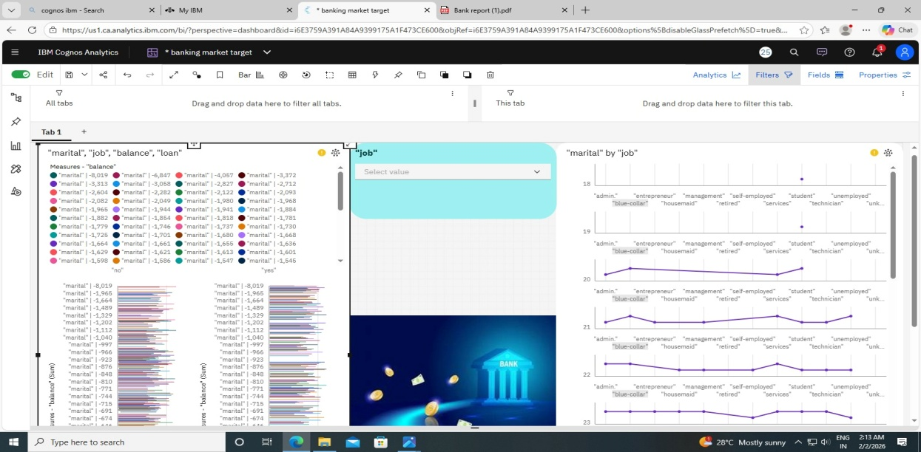

CONCLUSION
The Bank Marketing Target Analysis project successfully demonstrates the importance of data analytics in improving marketing strategies within the banking sector. By analyzing customer demographic, financial, and campaign-related data, the project identifies key factors that influence a customer’s decision to subscribe to a term deposit. The use of exploratory data analysis and visualization techniques provides meaningful insights into customer behavior and campaign effectiveness.
The findings show that proper customer targeting, optimized communication methods, and reduced unnecessary contacts can significantly increase marketing success rates while lowering operational costs. This project highlights how data-driven decision-making can enhance business performance and supports the adoption of analytical approaches in modern banking systems. Overall, the project aligns with IBM’s data analytics standards and showcases practical, real-world problem-solving skills.

REFERENCE
- click here to dataset
- click here to git

